Sailing Race Manager User Manual

Sailing Race Manager is a web application that manages and scores sailing races. It conforms to the Low Scoring Rules set out by the RYA in their “Racing Rules and Guidance” publication.

The Portsmouth Yardstick Handicap System is used to correct times.

Quick start Guide
Upon opening sailing race manager, you will be greeted with the following page:

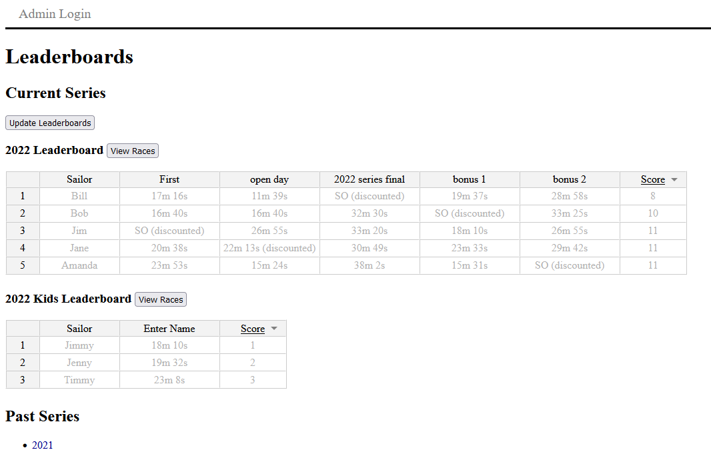
The leader boards for Series that are currently ongoing (races still being added) are displayed here.

The leader boards show the corrected times of each participant in each race and their current score for the series.

You can sort the participants by any column, by double-clicking on the column headers. This allows you to easily see the winner of each race.

To see the individual race results, raw times and other details, click on the “view races” button.

If you want to review the results of old Series that have finished, they are listed at the bottom of the page.

Click the “Admin login” button at the top of the page to login to the admin portal. This allows you into add and edit races and sailors.
Login with the admin password. The default password is “admin”

You should be greeted with a page like that below:
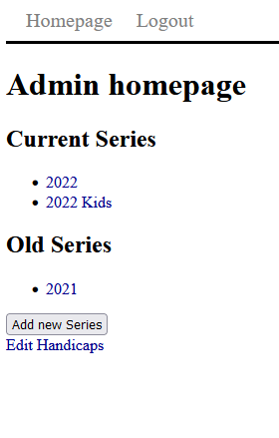

Click the “Add new Series” button to add start a new series, or select one from the list to edit it.

You can view and edit the RYA handicap numbers, by selecting “Edit handicaps”

You should now be looking at a page like the following:
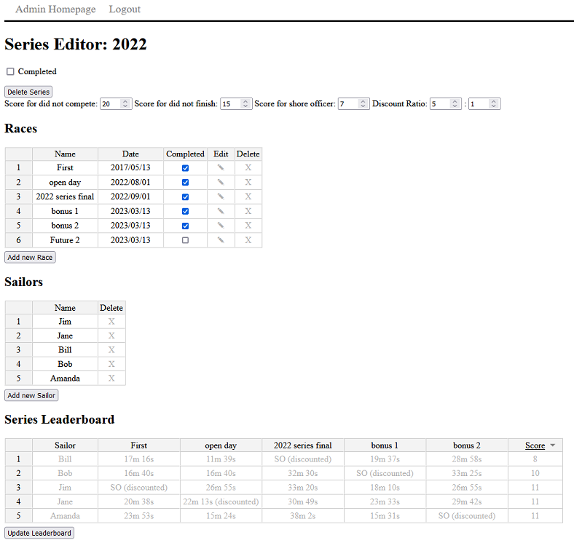

Here you can add races and sailors to the Series, and edit their details.

Sailors are automatically entered into every race.
At the top of the page, you can change some options for the entire series, such as marking it complete, penalty scores, and the discount ratio.
Discount ratio discounts some of the sailor's lowest scores from the total. For example, a ratio of 5:2 means for every 5 races, discount the 2 races with the worst score for each sailor.
You can edit any item in the tables by double-clicking on it. You can delete a sailor or a series by clicking on the "X" in each row.
Only races that are marked as completed are counted in score calculations.
Click the "update leader board" button to see the Leader Board updated with your changes.

Click on the edit (“✎”) button to start adding race results to a race.
You should now see a page like that below:

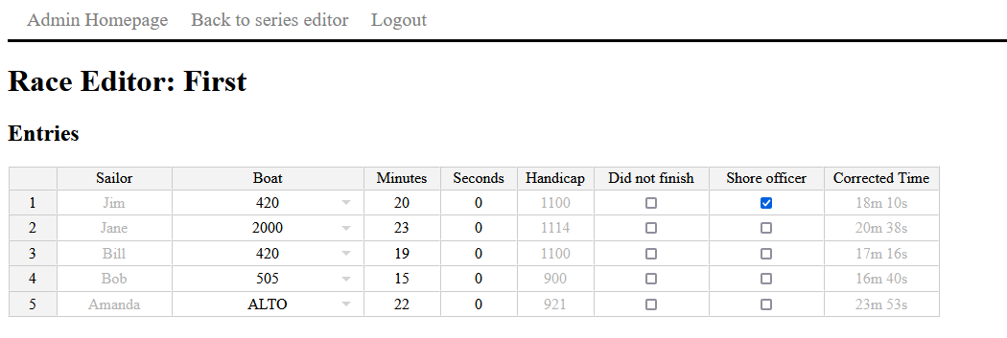

Here you can select what boat each participant sailed, and enter the raw time. The corrected time is automatically calculated for you.

You can also set the shore officer and Did Not Finish options to apply the correct penalty scores

All sailors in a series are automaticity entered into every race.

A time value of “0:00” indicates a participant did not compete in the race, and the associated penalty points are awarded.

